**SYSTEM ANALYSIS**

**2.1 Background Research**

With the advancement of technology in these days, learning inside a classroom is not the only way to study. Because of the rapid development of Information Technology & internet- based things, e-learning, distance learning, mobile learning has emerged. So, anyone can involve in their studies at anywhere & any time.

As an example, when we consider about a traditional classroom, it’s full with uniformity and if we talk about the students, the capacity of each student is different. Some students get more time to understand. Moreover, the engagement between students and teachers are less. Nevertheless, sometimes they are not focusing. But using LMS reduces those problems, not only that but also to continue studies even on pandemics like we face on these days.

What is LMS? Learning Management System (LMS) is a concept which is integrating with multiple media, multiple languages and multiple technologies to present, create, evaluate and fulfill educational purposes and frequently they are rich with multiple tools and functions to enable modern learning environment. LMS creates an interaction between the communication devices and participants by providing attractive interfaces.

**Throwback to initiating stage – current stage of LMSs**

In 90s, the first LMS was innovated along with the first web browsers, but it was criticized as they believe these technologies are harmful. Before it migrates to the web era, LMS was designed to serve individual institution Learning requirements only.

Over the past few years Learning Management systems were designed using different technologies like cloud computing, web programming languages, java, php, MySQL, Java Script…etc) and has given more interest in users preferences.

When we talk about the current Learning Management Systems, they are going under the Global Standards for LTI and APIs. Inside the LMS granting access to content and materials working on LMS environment. If we consider about current LMS most of them are web based.

Current LMS organizes as courses, courses divided into modules, each module contains lessons. LMS functionalities are Students & lecturers login, Face-to-face learning, e-book libraries, automatically generated tests, chats, forums, blogs, video blogs, watching videos, assignment submissions, Calendar, ask questions.

**2.2 Fact gathering technics**

One of the most important steps in analysis phase is requirement gathering. We have used suitable fact gathering technics to develop and implement the current system.

1. Understanding the background & record view

We Studied Information related to the current system which is already available as documents, articles, records and published materials (magazines, papers). It is one of the fastest and independent ways to gather information and used to prepare further questionnaires.

1. Queries

Taken as a whole, in society there are students those who have used LMS and those who haven’t. taking their ideas and responds is much more important. For that, considering the current situation in our country we are unable to conduct face-to-face interviews or observations. So, we created and shared a google forum as a questionnaire. We were able to get an idea and a feedback about the current system and what they thought about adding new features and was able to get their ideas too.

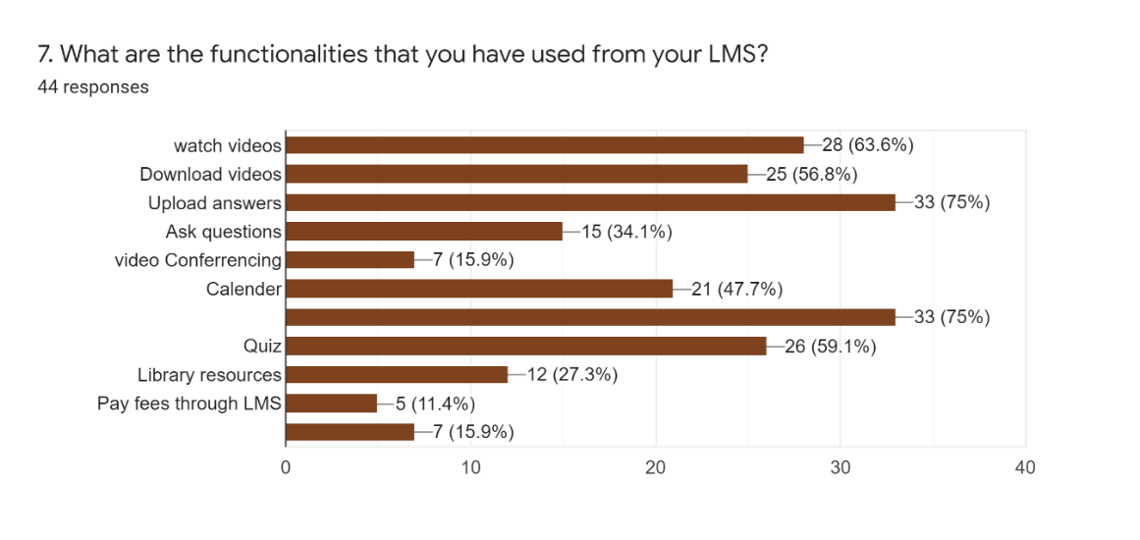

Fig.2.21 Graphical representation after obtaining the results of the questioner about LMS (2.21)

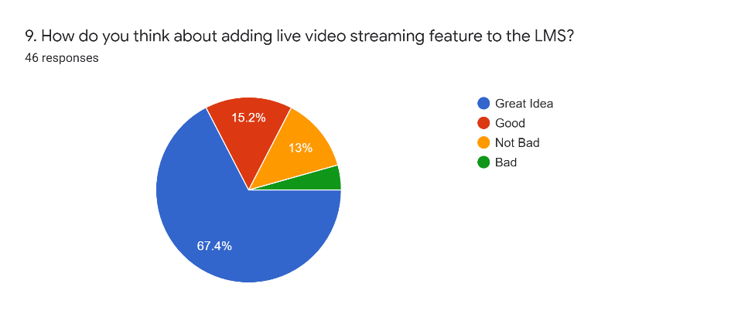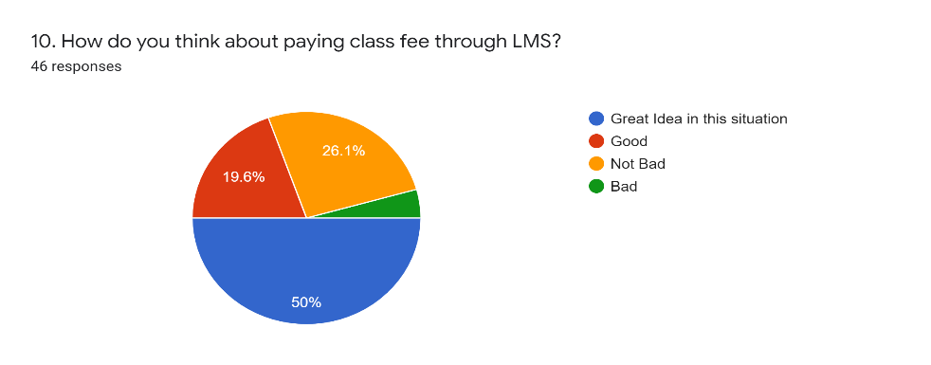We aware our audience about new feature that we are going to add and their opinion.

Fig. 2.22 Graphical representation after obtaining results regarding to adding new features

Online Conferences

The requirement of creating new LMS with advance features was given by a English Lecturer Mr. Pathum Wickramasinghe. He and his students face lots of troubles in Learning and studying with this COVID situation. Not only that he faces troubles when charging class fees. Eventually he wanted a solution for this matter. So, he brought this matter to us and we are trying to help by designing new LMS. So, every time we connect with him using video conferences and knowing his requirements.

Remote interviews

We hold remote interviews with students & clients.

Draw back of current system

Issues of current system, how they overcome, Manage & find solutions

Usability related issues- A LMS should be easy to use everyone. It should not be a mystery. There are lot of people with inexperienced with IT knowledge.

1. Ambiguity GUI designs

When we are using LMS we are dealing with UIs. If they seem difficult, users will be confusing.

1. Glitches in accessing LMS

When we try to access our software, it should be bringing us step by step closer to achieve our purpose. No one need to waste time.

1. Inability to connect with 3rd parties

The current Learning Management Systems are not fully with all the features. So, users have to work with other third-party tools. (this is one reason; we need to implement new LMS with all features)

1. Another major drawback of LMS is there is no fixed UX for mobile phones. Today mobile phones ahead than other devices like desktop computers, laptops. So, it is essential to access their content using mobile devices. That’s why LMS needs fixed, adaptive, fluid, responsive layouts.
2. After a while student demotivated an lose their interest in using LMS.

Using many systems to maintain and tracking user data. Sometime the relevant data can be stored in multiple locations. So, users have to sign in with different systems.

A LMS with wide APIs and Integrating libraries let to exchange data with other integrating organization’s third party HRIS, HRMS, databases. Data from different platforms can be access using single LMS. Single sign on, SSO avoid login multiple systems. No need of remembering multiple user names & passwords. One student requires one credential to access various facilities.

Ex: University of Plymouth LMS

Disadvantages

Student’s Side

1. Even if the education is done using e-learning, when you coming to the industry, they require physical skills which you can’t learn online. People can face exams online, but when they come up with real life scenario, they need physical skills and ability.

1. The tunnel effect- another drawback of learning through LMS is student’s tunnel vision. They don’t know about other learning opportunities outside the LMS. They don’t know the competition outside world.
2. Physical training can’t be fully replaced by Online training.

Many researches point out that it takes more 40%-60% time to e-learning than traditional classroom learning. And there’s a big possibility of drifting off from their learning while e-learning

Administrative Side

1. Cost for implementation, set up, purchasing, maintaining & security is high

Lecturers Side

Most of lecturers don’t have better knowledge in IT. Somehow a bit of IT knowledge needs to use effectively.

Another challenge is to create learning activities for students using lecturer’s technical styles and capacities.

How to Manage issues (How LMS addresses those above issues)

For student’s demotivation after sometime, LMS provides bridges to connect with social media and with other technical tools. It helps to make this journey attractive. LMS provides an interface to create users own content.

And another strategy they use is creating attractive GUIs. Not only that many users both lecturers and students are not good in IT so, now they always provide user friendly user interfaces and icons.

A mixed learning approach (combine with traditional face-to-face instruction with self-paced learning) And using standard compliant like (SCORM, AICC and xAPI/ Tin Can) and non-standard compliant(live streaming, uploading documents) .

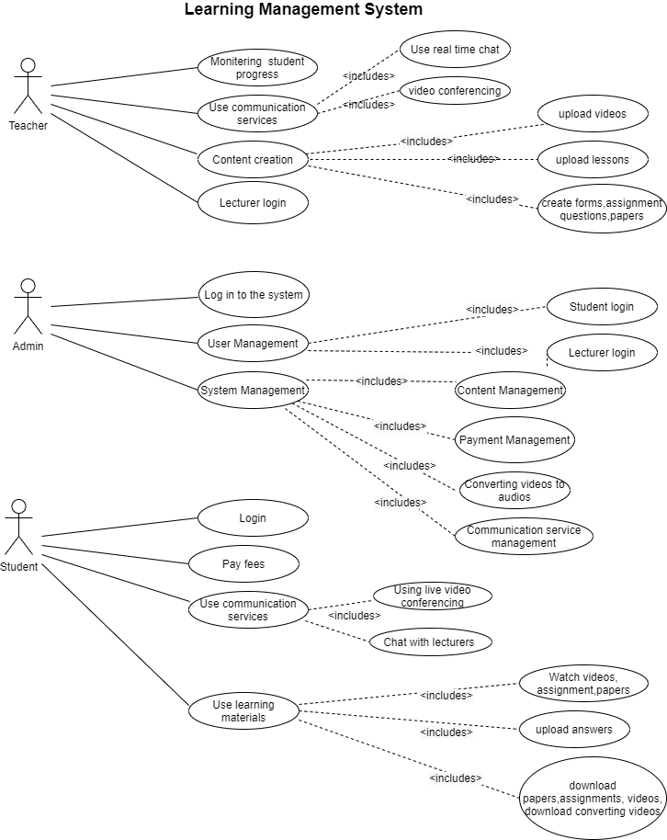Use case diagram

Summary

This chapter tries to evolve you the background of the current Learning Management Systems. How it has evolved over the past years. Furthermore, doing an analyze before the project design and implementation is very essential. By that we can get an idea about how users involve with current system, issues that arise when using LMS (Usability issues, technical issues), Disadvantages & how developers have managed them.